**Dairy Management System**

Requirements:

Java Version 8 needs to be set as classpath from system environment as show below:

From Control Panel > All Control Panel Item > System

Open Advanced system settings > Environment Variables > JAVA_HOME to Java Version 8

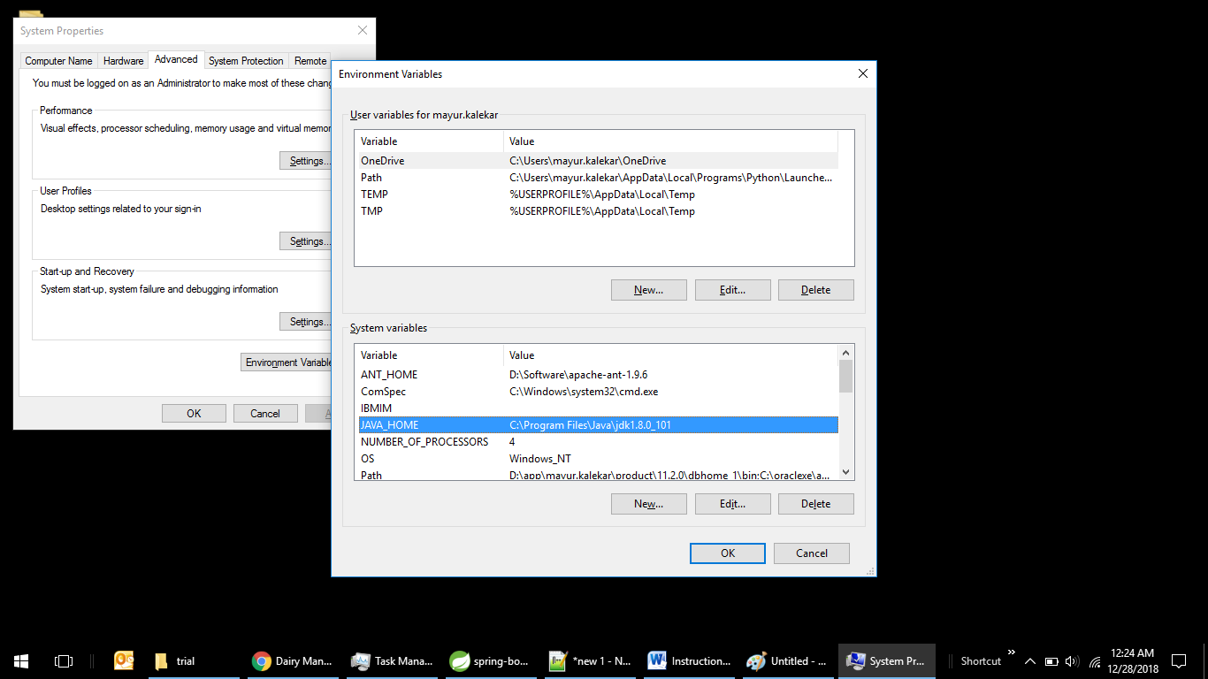

Once Java version 8 is set go to folder where dms-trial.jar is present and open cmd prmpt

And run following command

Java –jar dms-trial.jar

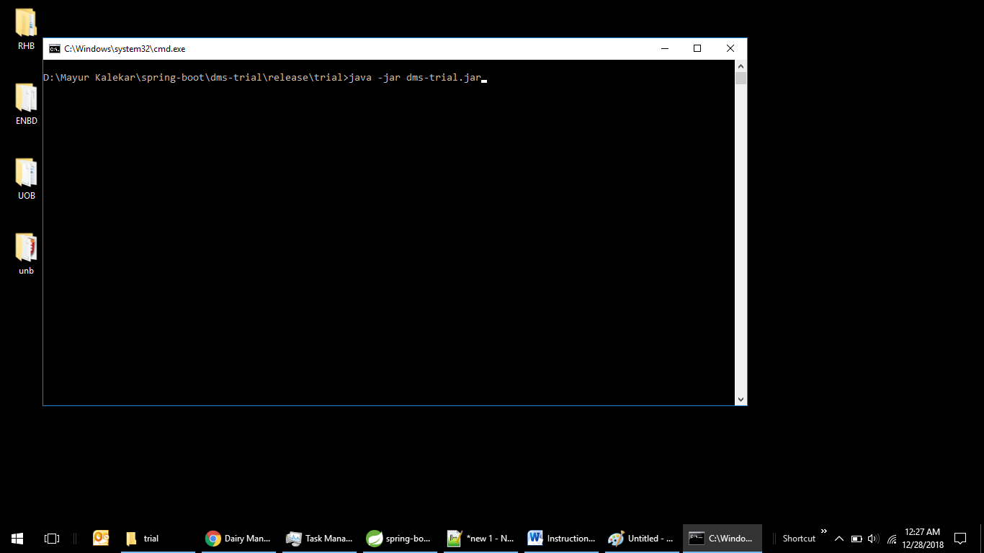

Following will be the result and application will be up on below url:

http:localhost:8080/dms or use ipconfig to get ipv4 address and replace it with localhost

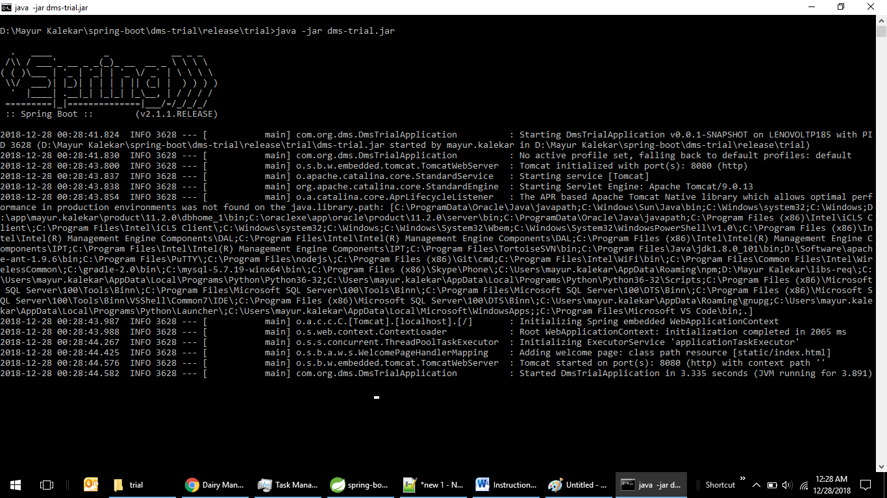

Following will be the first screen on start

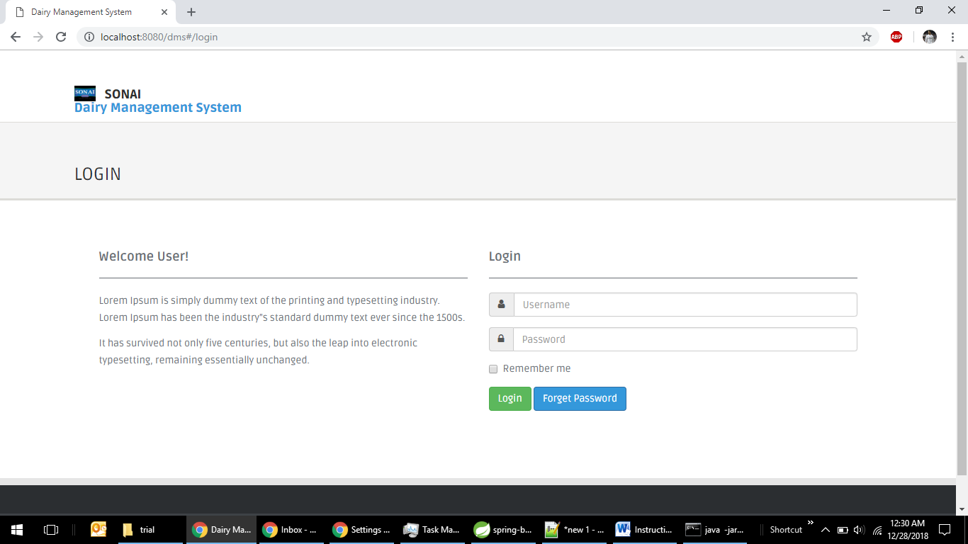

**Current trial application is not connected to any datasource so mock data is used to explain the features**. **So some features will be available but functionality will be blocked like view/edit/approve/reject hyperlink.**

**Note**: While delivering the product to client 2 users will be created which will be sysadmin(maker and checker).They will be responsible for created all types of users. So there will be no signup form for new users.User need to seek there higher authority for creation of accounts. Below is hierarchy of roles

System Admin(maker/checker) -> MD - > CP -> LC -> FR

1. System Admin can create all types of users and maintain them but cannot access other services.

Rest customer will follow as explained.

1. Main Dairy (MD)

Menu access : Maintain Listing>(Manage User{All roles below the hierarchy},Parameters{All roles below the hierarchy}) ,Process>(Manage Upload{All roles below the hierarchy},View Pricing),Profile

2. Chilling Plant (CP)

Menu access : Maintain Listing>(Manage User{All roles below the hierarchy},Parameters{All roles below the hierarchy}) ,Process>(Manage Upload{All roles below the hierarchy},View Pricing),Profile

3. Local Collector (LC)

Menu access : Maintain Listing>(Manage User{All roles below the hierarchy},Parameters{All roles below the hierarchy}) ,Process>(Manage Upload{All roles below the hierarchy},View Pricing),Profile

4. Farmer or Milkman (FR)

Menu access: Process>( View Pricing),Profile

You can login with any valid username and password. Current trial/prototype has full access of menus and access right to demonstrate the functionality. The final model will follow restriction as mentioned above.

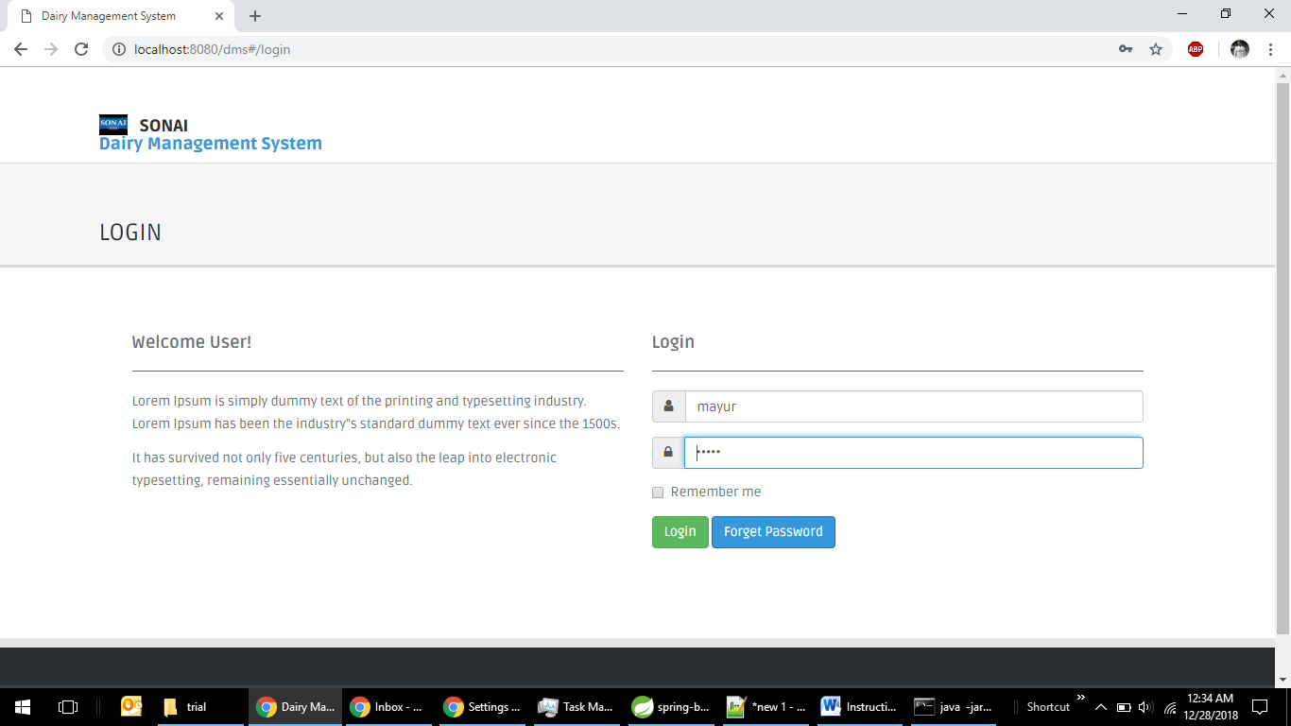

Once to press login following screen will be appeared.

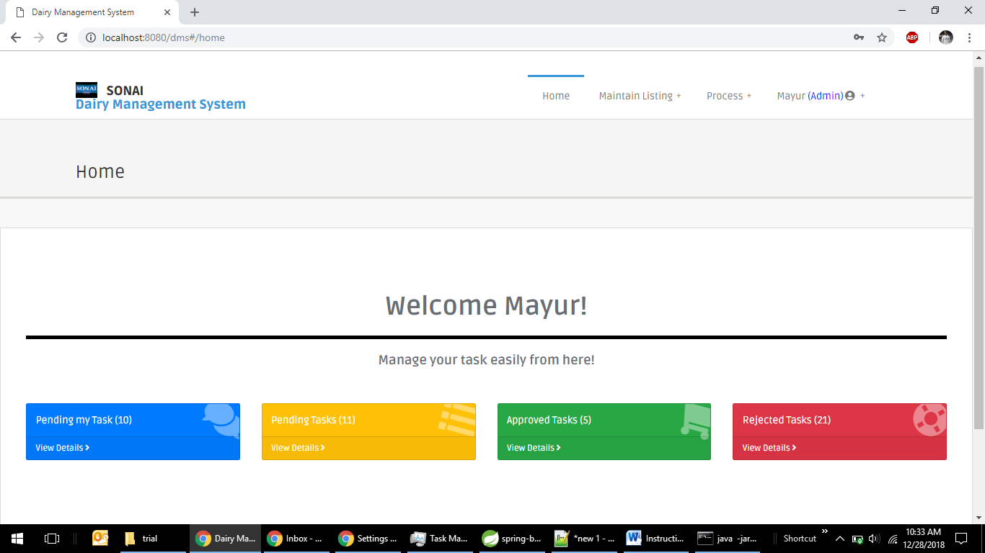

So above screen consists of menus which consists of Home, Maintain Listing, Process, User Profile

1. Home menu

Home menu will contain a Welcome note with user name and four cards as pending my tasks, pending tasks, approved tasks and rejected tasks.

Tasks currently means customer creation/maintenance or milk upload tasks

1. Pending my Tasks: This are tasks which are submitted by current user to higher authority which yet not approved by the higher authority.
2. Pending tasks: This are tasks assigned to current user which needs approval/rejection as a higher authority
3. Approved tasks: This are tasks which are submitted by current user which are in approved state.
4. Rejected tasks: This are tasks which are submitted by current user which are in Rejected state.

For Tasks created by sysadmin(maker) higher authority will be sysadmin(checker) vice versa.

1. Maintain Listing Menu

Maintain Listing menu consists of below submenu

1. Manage User : This show list of customer created by current user and also allow them to create new user if they have access of creating new user. Following is the workflow.

Workflow for customer creation/maintenance of system admin

System Admin(Maker)

APPROVE

SUBMIT

SUBMIT

System Admin(Checker)

Workflow of customer creation/maintenance of main user

Main Dairy(MD)

Approval

Chilling Plant(CP)

Creates User(CP) of lower hierarchy without approval

Create and submit user of role(LC) of lower hierarchy.

Approval

Create and submit user(FR) of role of lower hierarchy.

Local Collector(LC)

Farmer/Milkman(FR)

1. Parameters

Parameters will contain list of hard coded value which will be used for various module for calculation purposes for example Cost of milk of current day. Screen will be as below.

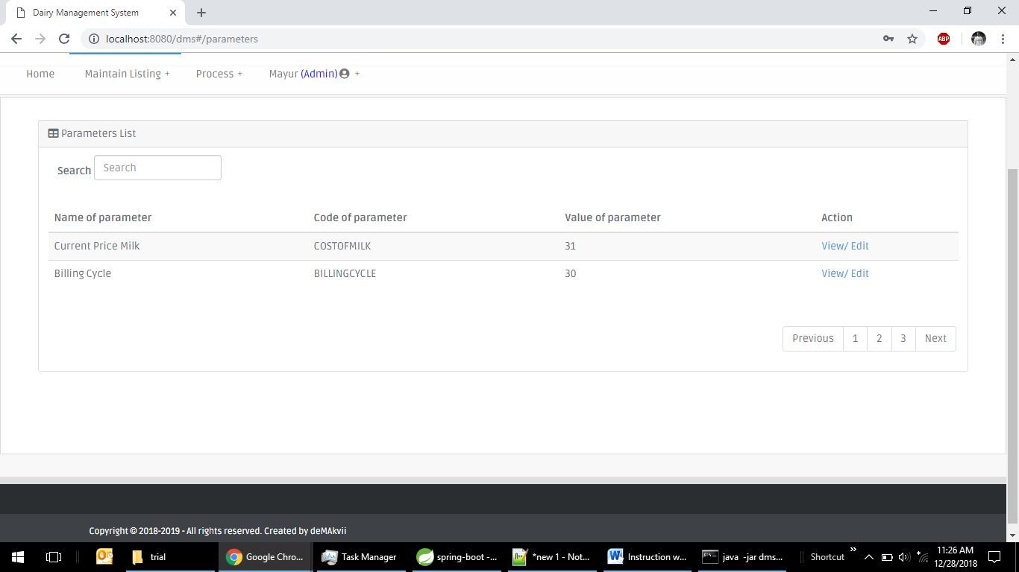

3. Process Menu:

Process menu will have to sub menu Manage upload and view pricing

1. Manage upload

On clicking manage upload, list of uploads of current user and users below current user’s hierarchy will be shown with upload button depending upon access rights.

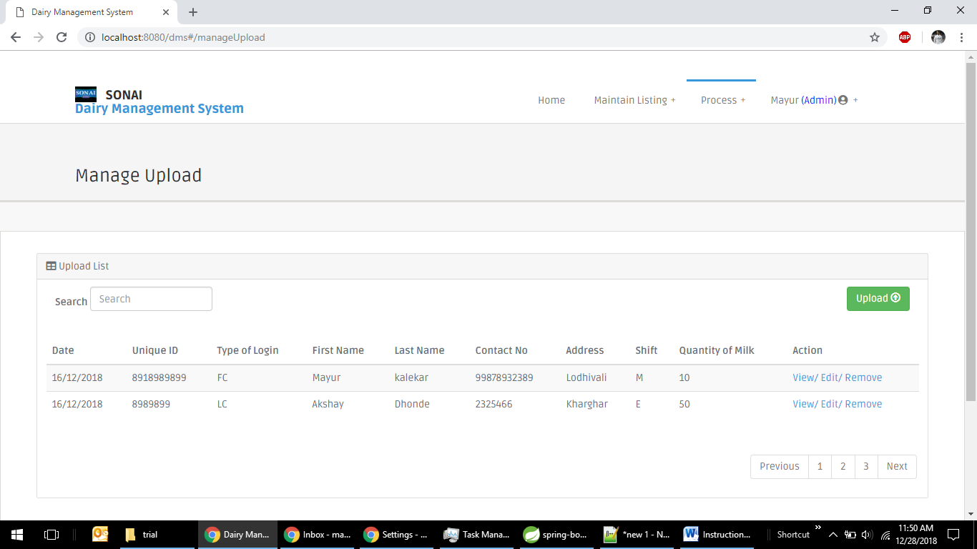

On clicking upload user can upload his milk deposit excel format file to system. Then system will validate and forward it to higher authority for approval. Once it is approved it will calculated amount to pay to the supplier and will be appeared in view pricing list (Process > View pricing) for that date for the user

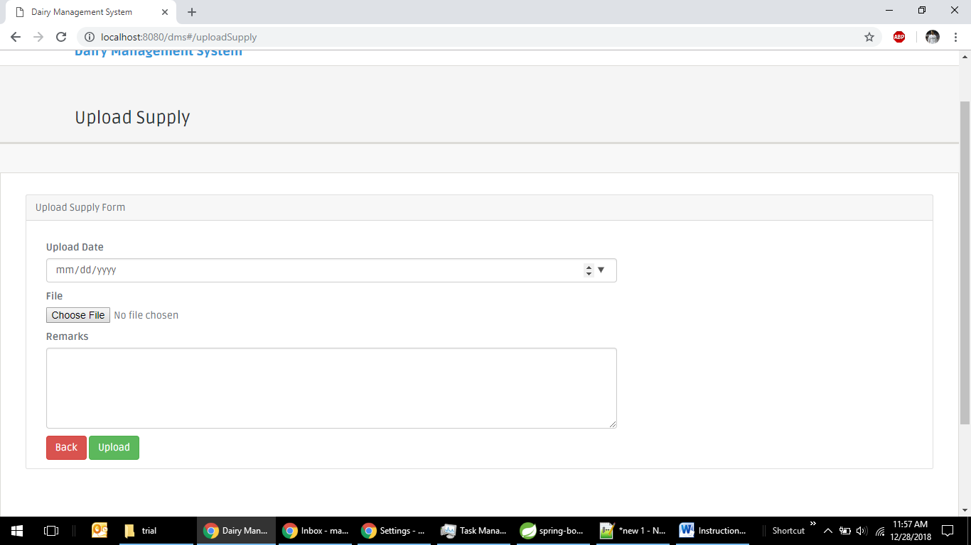

Workflow of supply upload

Main Dairy(MD)

Approves/Rejects upload by CP

Uploads and submit to MD.

**Chilling Plant(CP)**

Uploads for farmer/milkman and submit to CP.

Approves/Rejects upload by LC

**Local Collector (LC)**

Submit Details to LC

**Farmer or milkman (FR)**

1. View Pricing

On click of view pricing following screen will display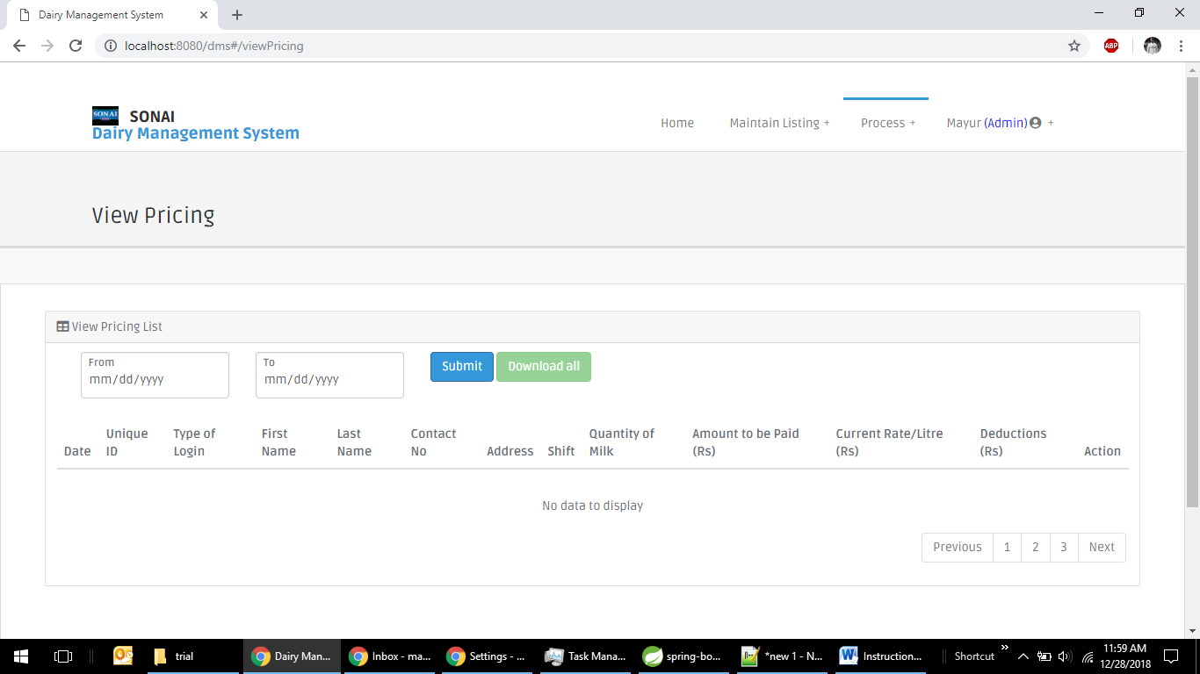

User has to fill in from and to date and hit submit to get list of upload of current user by date.

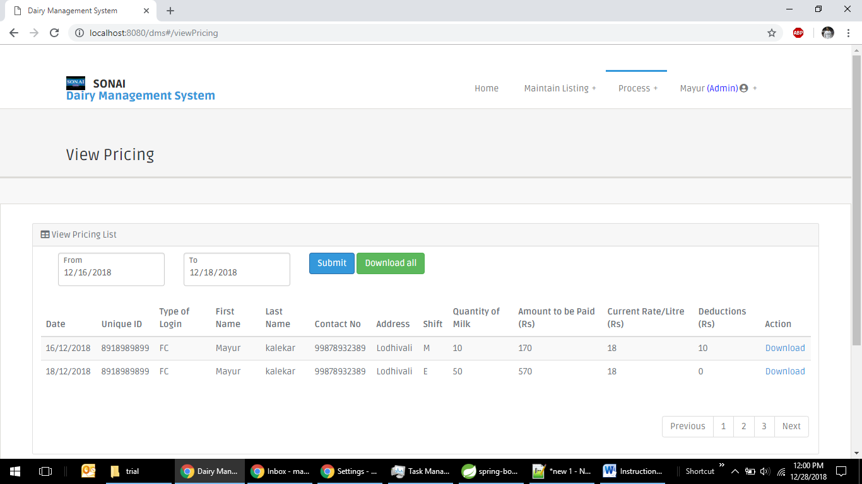

After submit, list will appear and download all button will be enabled which will help to user to download all results into one excel. User can download date wise too by clicking download for that date.

This result will be final calculation of milk for that user based on milk cost for that date.

4. Profile Menu:

Profile will have 3 submenus which are settings, change password, logout

1. Settings

Current user will be able to edit his/her details from this menu

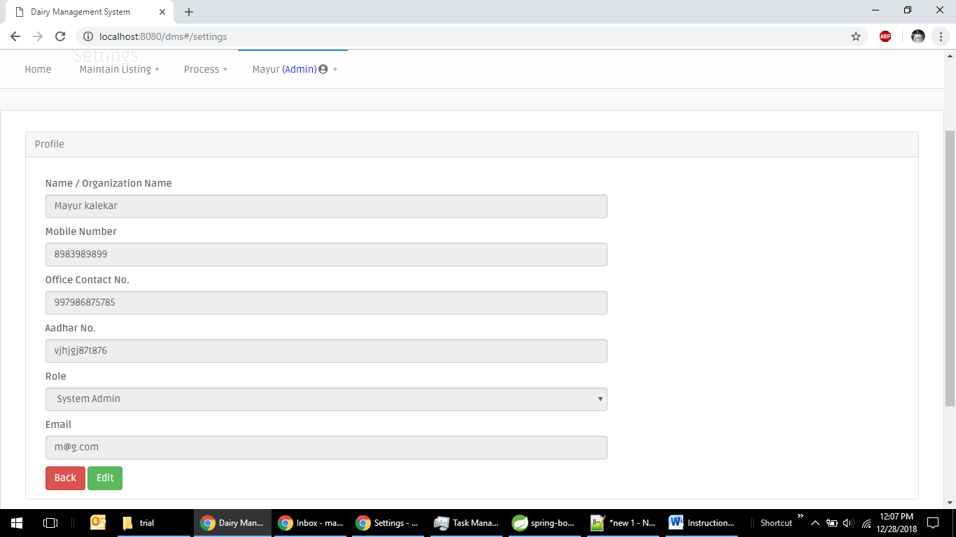

2.Change password

This menu will help to change current user password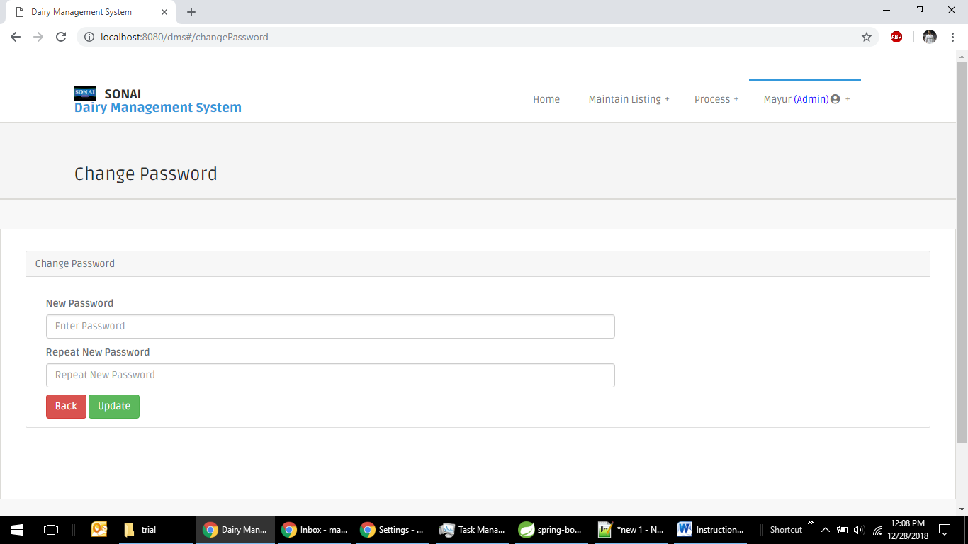

3. Logout

This submenu will help user to logout from the application/services.